Doc. No.: IIUM/204/6/8/1 (COPY)/f-01
Version no.: 01
Revision no.: 03
Effective date: 07 April 2022

COPYRIGHT DISCLOSURE FORM

Copyright Unit
Tel: 03-6421 3826 / 3866 Fax: 03-6421 4855 email: crlib@iium.edu.my

Kindly disclose your invention through this Copyright Disclosure Form for Intellectual Property (IP) Protection and Registration.

PART 1: IDENTIFICATION
- Principal Inventor Identification

NAME OF PRINCIPAL INVENTOR & STAFF NO.
IC / PASSPORT NO.
DEPARTMENT & KULLIYAH
CORRESPONDENCE ADDRESS
EMAIL
OFFICE TEL. NO. &
H/P TEL. NO.

IMPORTANT REMINDER: -
Please state the details of the inventor/originator/co-inventor(s) in Attachment 1.

 |  |  | Intellectual Property (IP)  (Please tick √ in the box) |  |  |  |  | Sub Type  (Please tick √ in the box)
 |  |  |  | Copyright |  |  |  |  |  |  | Literary |  |  |  |  | Musical |  |  |  | Artistic
 |  |  |  |  |  |  |  |  |  |  | Film |  |  |  |  | Sound |  |  |  | Others
Definition |  |  |  |  | Duration of Protection |  |  |  |  |  |  | Notes
Copyright is the exclusive right to control creative works created by the author, copyright owner and performer for a specific period governed under the Copyright Act 1987. |  |  |  |  | -Literary, Musical or Artistic Works  50 years after the death.  -Film, Sound Recordings and Performer  50 years from the work was published.  -Broadcasts  50 years from which the broadcasts was first made. |  |  |  |  |  |  | Works Eligible for Copyright  - literary works;  - musical works;  - artistic works;  - films;  - sound recordings;  - broadcasts; and  - derivative works

PART 2: DESCRIPTION OF DISCLOSURE

- Title of disclosure
_______________________________________________________________________________________________________________________________________________________________________________________________________________________________________________________________

- Brief Description of the Disclosure
__________________________________________________________________________________________________________________________________________________________________________________________________________________________________________________________

- Usage of the Disclosure
__________________________________________________________________________________________________________________________________________________________________________________________________________________________________________________________

- Please attach the document below (Please tick √ in the box if attached)

Detail backgrounds, description, and the document file.
The originality report by plagiarism software (TurnItIn) for manuscript (Only originality report with green range (1-24%) will be considered)

5. Date of document fixation / first created

_______ (DD) /_______ (MM) /________ (YYYY)

PART 3: SOURCE OF RESEARCH PROJECT(S) RESULTING TO THIS DISCLOSURE

- Funded Project
No. | Fund Type | Project Code | Start / End | Fund Amount | Fund Allocation of IP
0 | Sample: IRPA / FRGS / SF/ TF/ RIGS / | 01-03-06-SF1001 | 31/07/2015 – 30/06/2017 | RM 254,000.00 | RM 20,000.00

- Obligation to Funded Project
Do you have any obligation to the funded project e.g. Disclosure of IP, commercial grant of rights (option/license) ? |  | Yes |  | No
If Yes, please specify any obligation to the funder

- Project Cost Estimation
Please estimate the cost leading to the invention (for sample, please refer to Attachment 3)

Vote | Items Details | Estimated Cost (RM) | Source of Fund | Notes
Wages / Cost of RA
Travel and Transportation
Rentals
Research Materials Supplies
Modifications and Repairs
Special Services
Equipment and Accessories
Total

PART 4: COMMERCIAL POTENTIAL
- Please circle (O) the stage of the disclosure

- Can this invention be exploited for commercialization directly, or does it need further development?
__________________________________________________

- If there is commercial potential, please do initial competitor analysis as per Attachment 2.

Attachment 2 (Initial Competitor Analysis)

- Please state if there is any inquiry on the Invention from the industry.

Yes No

If Yes, please specify and state the name of the interested party.
_________________________________________________

PART 5: DECLARATION AND RECOMMENDATION

DECLARATION
(Please tick √ in the box)
I have discussed this intellectual property with the Head of Research representative for my Kulliyyah

I have discussed the content of this intellectual property disclosure and obtained consent for its submission with my co-inventor/s and co-contributor/s
I understand that the assignment of the Intellectual Property Right to International Islamic University shall follow IIUM Policies and Guidelines for Intellectual Property Rights and Commercialization
I promise to work with Dar Al-Hikmah Library/assigned expert/ agents to complete the full registration of my intellectual property
I declare that this disclosure is an original work and belongs to the undersign and the listed inventor, and I/We will be responsible for any infringement

______________________ ________________
Signature of Principle Inventor Date

RECOMMENDATION OF THE
HEAD OF RESEARCH
______________________ _______________
Signature and name of the approving authority Date

Attachment 1: List of Inventors and Co-Inventors

Name & Staff No./Matric No. | Department & Kulliyyah | Type | No. of Man Hours Spent | Contribution % | IC/  Passport No. | Nationality | Address | Tel No | Signature
Sample:  Name of Inventor/Co-Inventor/Investigator/  Co Investigator/  Contributor & Staff No./  Matric No. | Department & Kulliyyah  (Biotechnology, KOE) | - IIUM Faculty (Title and grade)  - IIUM Staff (Title and Grade)  - Student (Undergrad/  Grad/ Post Grad/Post Doc)  - Ex-Student/Non IIUM (Please state University/Industry) | Total man-hours spent on the invention | %  Share of the royalty if the IP is to be commercialized
Total |  |  |  | 100%

Attachment 2: Initial Competitor Analysis

Only for Invention that has potential commercialization

Product Name | Manufacturer/Producer | Model | Competitor Price | Product attributes | Comparison to the disclosed IP
Sample: Payung ACME | ACME | ACME 123 | RM 2,000 | A fire protection umbrella, which comprises a fire-proof umbrella cover coated with fire retarding paint and fully covered with ceramic elements or ceramic wafers. A flash light is attached to the handle of the umbrella to produce light. A hood is attached to the bottom of the umbrella cover to cover one's head on an emergency. The umbrella ribs may be bound up with the shaft of the umbrella frame by a cord to prevent the umbrella cover from collapse in counter direction so that the umbrella may be used as a parachute to help one escape from a high-raised building.

Attachment 3: Sample Project Cost Estimation

Project Cost Estimation

Vote | Items Details | Estimated Cost (RM) | Source of Fund | Notes
V11000 Wages | Research Assistant | 32,200 | FRGS
V21000 Travel and Transportation | Local and Overseas Travel | 19,000 | FRGS
V24000 Rentals | Usage of EE Lab | 15,000 | IIUM Operating Expense | The use of Lab for 6 months
V26000 Research Materials and Supplies | Raw materials | 20,000 | FRGS, IIUM Operating Expense | Chemical and electronic parts
V28000 Modifications and Repairs | Spare parts replacement/  Calibration | 5,020 | IIUM Operating Expense
V29000 Special Services | External Lab charges/ Outsourcing/ External consultant | 16,000 | FRGS, IIUM Operating Expense
V35000 Equipment and Accessories | New equipment | 115,002 | FRGS
Total |  | RM 222,222

IIUM Guideline for Intellectual Property Disclosure at various stage of R&D&C&I

Please note that the graphical diagram is only a guideline of the stage to disclose Intellectual Property (IP) at IIUM. Actual disclosures and filing of IP may occur at any of the stage.

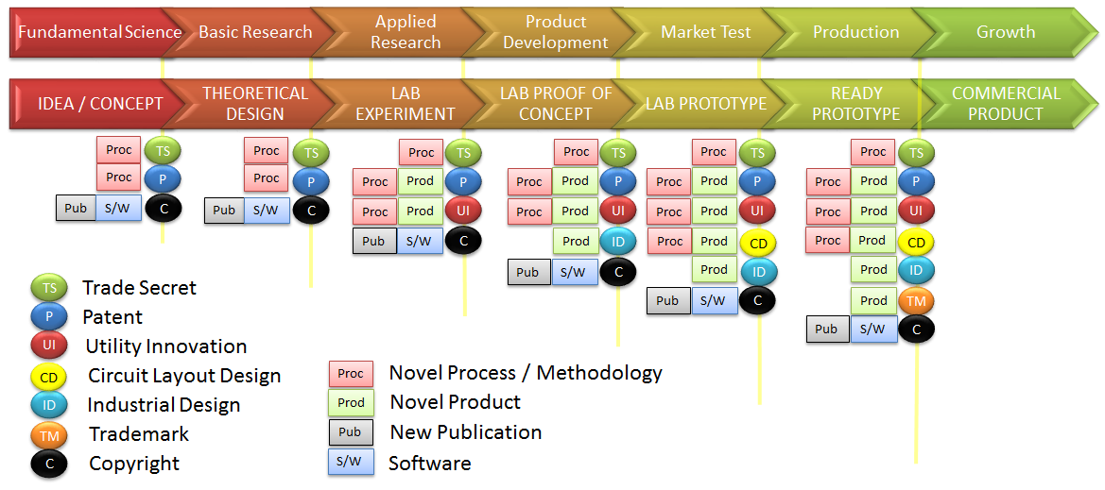

Technology Readiness Level (TRL)

TRL |  | Description
1 | Ideation | Basic Principles are observed and reported
2 | Innovation begins | Basic principles observed so practical applications can be formulated
3 | Proof of Concept | Analytical and laboratory studies are required to see if the technology is viable
4 | Component Test | Laboratory testing of the prototype component
5 | Prototype construction | Laboratory testing of the integrated system
6 | Alpha Testing | Prototype system demonstrated in an operational environment
7 | Beta Testing | Completed design tested in real environment
8 | Certification | Proven to work under its expected conditions and certified to be used
9 | System Proven to be successfully function | Ready for commercial deployment
9+ | Product is launched commercially

TPM Definition of TRL

https://www.youtube.com/watch?v=in4TnQZGYj4

Guideline: Format of work for copyright application

PRINTED
Document 1-25 pages | Printed or in softcopy/digital format
Document 26 pages and more | Prefer in softcopy /digital format

SOFTCOPY/DIGITAL FORMAT
Submit in CD-ROM only
Work type | Format
Literary | PDF, ZIP (Computer program)
Artistic | PDF/GIF/JPEG/PNG
Film | AVI/MPEG/MOV/MP4
Musical | MP3/WMV/PDF (MUSIC NOTES)
Sound | MP3/WMV

It is recommended that the work submitted for copyright application is in softcopy/digital format to expedite the filing process

